

**Embedded Systems Project**

**Firefighter Robot**

**Supervisor :**

**Prof. Belal Sababha**

**Authors:**

**Zeina Alruzoug 20210404**

**Hamdi AbuSabbah 20210918**

**Yousef Abu Shawreyeh 20200765**

Table of Contents :

TABLE OF CONTENTS

1 Abstract

1.2 Introducton and Background

1.3 Design

1.4 A. PIN16F877A Microcontroller

1.5 Overview of the Used Components

1.6. Software Design

1.7. Hardware Design

1.8. Conclusion and Problem Identification

**Abstract :**

This project presents the design and implementation of an autonomous firefighter robot using the PIC16F877A microcontroller. The robot is equipped with flame sensors, an ultrasonic sensor for obstacle detection, a servo motor , and a water pump system to extinguish detected flames. The system combines embedded electronics, control algorithms, and mechanical design to locate and eliminate fire hazards in a predefined environment. The robot is capable of detecting fire direction using multiple flame sensors and navigating around obstacles to reach and extinguish the source.

**Introduction and Background :**

In recent years, autonomous firefighting robots have become a vital research area due to their potential in preventing loss of life and property in fire-related accidents. Traditional firefighting methods rely heavily on human presence, which can be dangerous in hazardous environments. This project aims to develop a basic prototype of a fire-fighting robot that can detect and extinguish fire autonomously using embedded control systems. The system leverages the PIC16F877A microcontroller to process sensor data and control actuators including motors and a water pump.

**Design**

**Mechanical Design**

The robot is built on a four-wheeled chassis, powered by four individual DC motors, one for each wheel, providing stable movement and directional control. All components, including the microcontroller and wiring, are mounted on a base platform using a breadboard for connections.

The fire extinguishing system consists of:

**A water pump**, connected to a small onboard water reservoir via a plastic tube.

**A servo motor**, whose job is to move the plastic tube side-to-side, allowing the water to spray across a wider area when extinguishing a flame.

The robot uses three **flame sensors** (left, right, and center) to detect fire and activate the extinguishing mechanism.

**Electrical Design**

The heart of the system is the **PIC16F877A microcontroller**, which processes sensor inputs and controls the robot’s motors and actuators.

* **Power Supply:** A battery pack provides power to the microcontroller, sensors, motors, and pump.
* **Oscillator Circuit:** A crystal oscillator along with two capacitors is connected directly to the PIC16F877A’s **OSC1 and OSC2 pins** to provide a stable clock frequency for the microcontroller’s operation.
* **Reset Circuit:** Master Clear (MCLR) pin with a pull-up resistor enables manual or automatic reset.

**Sensors:**

* **Ultrasonic Sensor (HC-SR04):** Mounted at the front for obstacle detection.
* **Flame Sensors:**
  + Left and right sensors with digital outputs.
  + Center sensor with an analog output connected to the PIC’s ADC.

**Actuators:**

* **Four DC motors**—each connected to one of the four wheels—controlled by the **first H-Bridge motor driver**. This enables forward, backward, and turning motions.
* **Water pump**, controlled via the **second H-Bridge motor driver**, which allows for power control including on/off switching and PWM-based speed regulation.
* **Servo motor** used to rotate the plastic tube connected to the pump, sweeping the water spray across a wider area. The servo is controlled using PWM signals generated by the PIC’s CCP module.

All connections and components are arranged on a breadboard mounted on the chassis for easy assembly and troubleshooting.

**Software Design**

The embedded software is written in **Embedded C** using **MPLAB IDE**. The main functional blocks of the software include:

* **Sensor Reading Module:** Continuously reads data from the three flame sensors and the ultrasonic sensor.
* **Navigation Logic:** Based on flame sensor inputs, the robot determines the direction to move toward the fire while using ultrasonic data to avoid obstacles.
* **Firefighting Control:**
  + When a flame is detected, the microcontroller activates the water pump by controlling the second H-Bridge.
  + The servo motor sweeps the water spray tube left and right to cover a larger extinguishing area.
* **PWM Generation:** PWM signals are generated using the PIC’s CCP module to control the servo motor’s angle and the pump’s operation.
* **Motor Control:** The H-Bridge connected to the wheels is driven to move the robot forward, backward, or turn, as needed.

The program implements real-time control to ensure the robot responds immediately to flame detection and obstacle

**Overview of used components**

1. A PIC16F877A MICROCONTROLLER

The PIC16F877A is a widely used 8-bit microcontroller from Microchip Technology, known for its simplicity and reliability in embedded system projects. It features 40 pins, including 33 I/O pins, built-in ADC for reading analog sensors, and PWM capabilities for motor control. Its versatility makes it ideal for applications like robotics, automation, and real-time control. In this project, the PIC16F877A acts as the central controller, handling sensor inputs and managing outputs like motors, the water pump, and the servo motor.

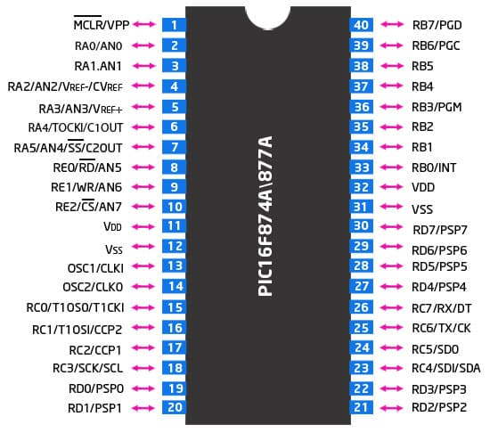

**Flame Sensors** (3 units total)

**Left Flame Sensor** (Digital)

Detects the presence of fire on the left side. Outputs a digital HIGH or LOW signal depending on flame detection. When a flame is nearby, the output goes LOW.

Connected to port RD0

**Right Flame Sensor** (Digital)

Identical to the left flame sensor but placed on the right side of the robot. Also outputs a HIGH/LOW signal based on flame presence.

Connected to port RD2

**Center Flame Sensor** (Analog)

Positioned at the front, this sensor provides an analog voltage that varies with flame intensity. The value is read through the PIC’s ADC (Analog-to-Digital Converter) to detect how close or strong the flame is. Connected on port RA0

And we have an extra Digital Flame sensor in the middle . Connected to port RD1

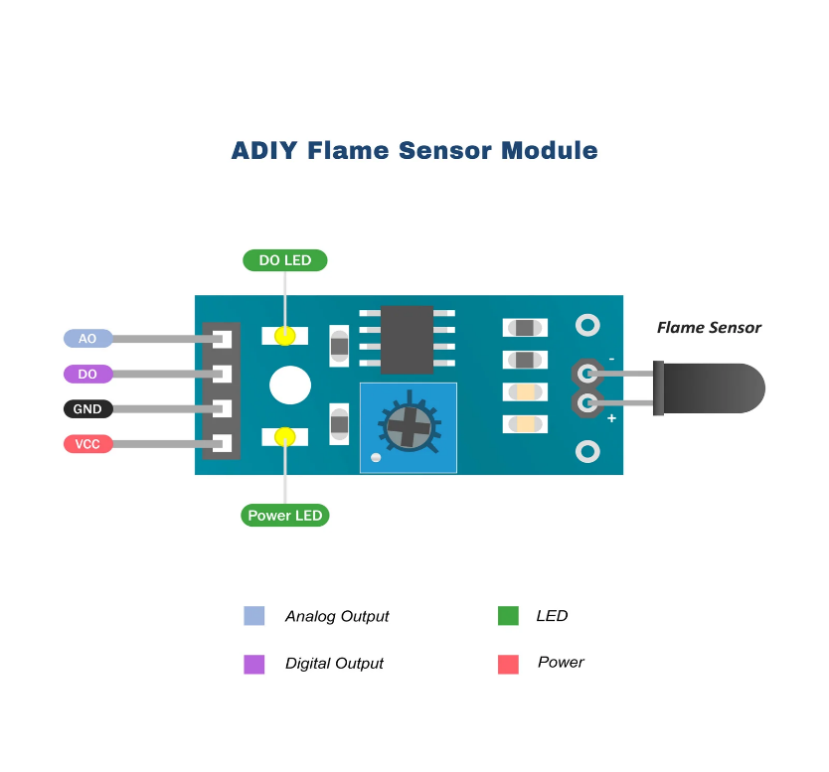

VCC → Connect to +5V

GND → Connect to Ground

**Ultrasonic Sensor** (HC-SR04)

Used for obstacle detection and distance measurement. It works by emitting an ultrasonic pulse and measuring the time it takes for the echo to return after bouncing off an object. This allows the robot to avoid obstacles while navigating toward the flame.

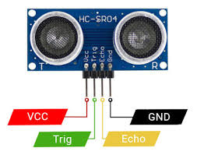

• **VCC** → +5V

• **GND** → Ground

• **Trig (Trigger Pin)** → **RE2** — Output from PIC

• **Echo (Echo Pin)** → **RE1**— Input to PIC

**H-Bridge**

H-Bridge 1: Controls the four DC motors for movement direction and speed by allowing current flow reversal.

H-Bridge 2: Controls the water pump’s operation, enabling it to be turned on/off .

Power Connections for H bridge one :

VCC (Motor Power) → Connect to Battery Positive (e.g., 6V–12V)

GND → Connect to common ground (shared with PIC and battery)

Control Pins (to PIC):

IN1, IN2 → Connect to RB0 and RB1 → Control Motor A (e.g., Left side)

IN3, IN4 → Connect to RB2 and RB3 → Control Motor B (e.g., Right side)

EN1, EN2 (Enable Pins, if present) → Connect to +5V.

Motor Ports:

RB0 Right Backward

RB1 Right Forward

RB2 Left Forward

RB3 Left Backward

H-Bridge 2: Controls Water Pump

Power Connections:

VCC (Motor Power) → Connect to Battery Positive (suitable for pump voltage)

GND → Connect to common ground

VCC (Logic) → Connect to +5V

Control Pins (to PIC):

IN3, IN4 → Connect to RD4 and ground

EN2→ Connect to +5V

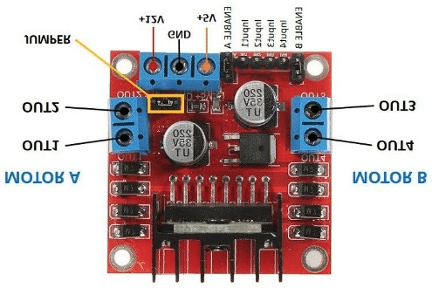

Water Pump

Pumps water through a plastic tube to extinguish flames. Activated when flame sensors detect fire. Controlled through the second H-Bridge.

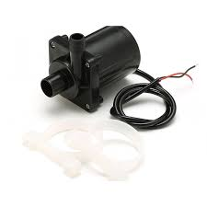

Servo Motor

Rotates the plastic water tube side-to-side to spray water over a wider area. Controlled by the PIC’s PWM output for precise angular positioning

The servo motor connections

CCP1 RC2



**Problem Identification**

Despite the successful implementation, several limitations were identified that offer opportunities for future improvement:

Limited Sensor Range: The flame sensors and ultrasonic sensor have a short detection range, making the robot less effective in larger or more complex environments.

Obstacle Navigation: The current navigation system is basic and may struggle in dynamic or cluttered environments.

Water Supply Capacity: The onboard water reservoir has limited capacity, restricting the robot's firefighting duration.

Power Management: Battery life can be a concern, especially when all actuators and sensors are active simultaneously.

Breadboard Assembly: Using a breadboard for connections introduces the risk of loose connections and is not ideal for long-term or real-world deployment.

**Software design**

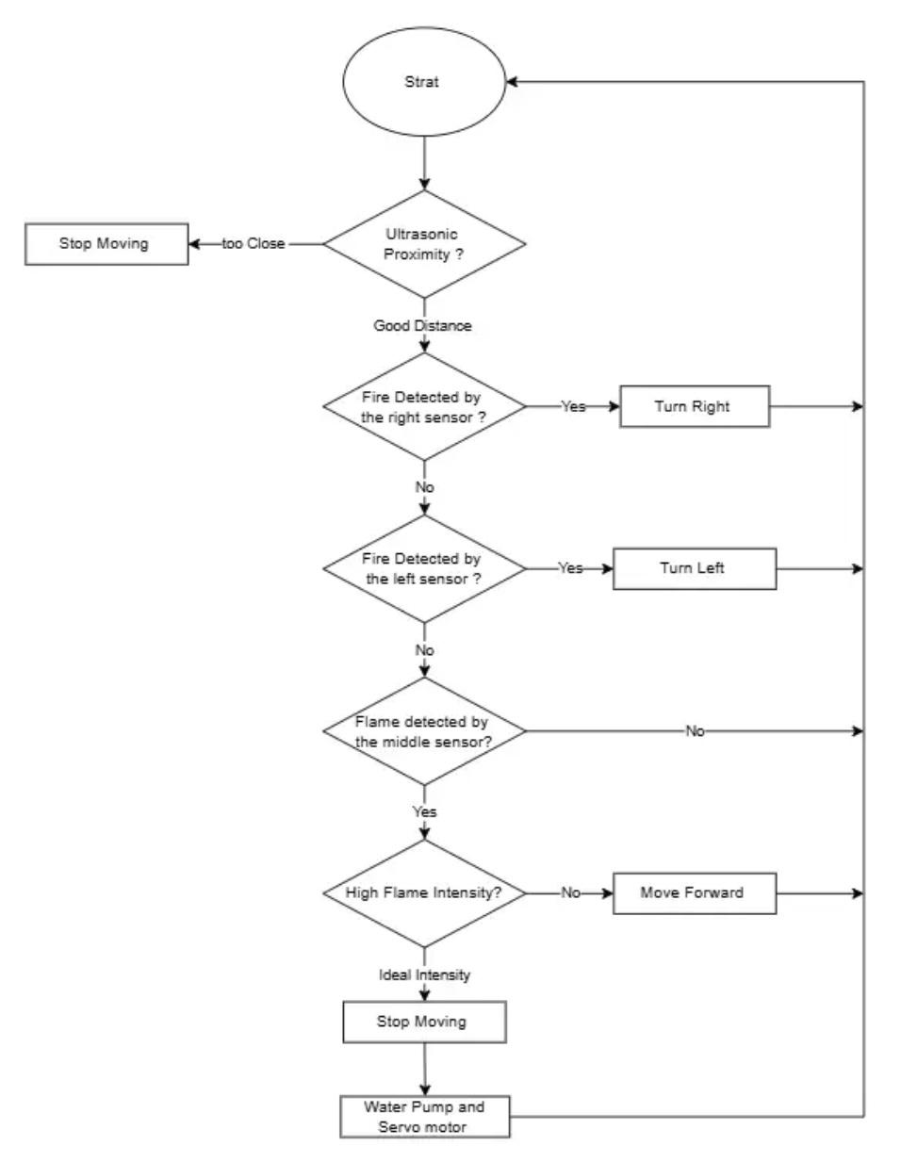

**Electrical Design**

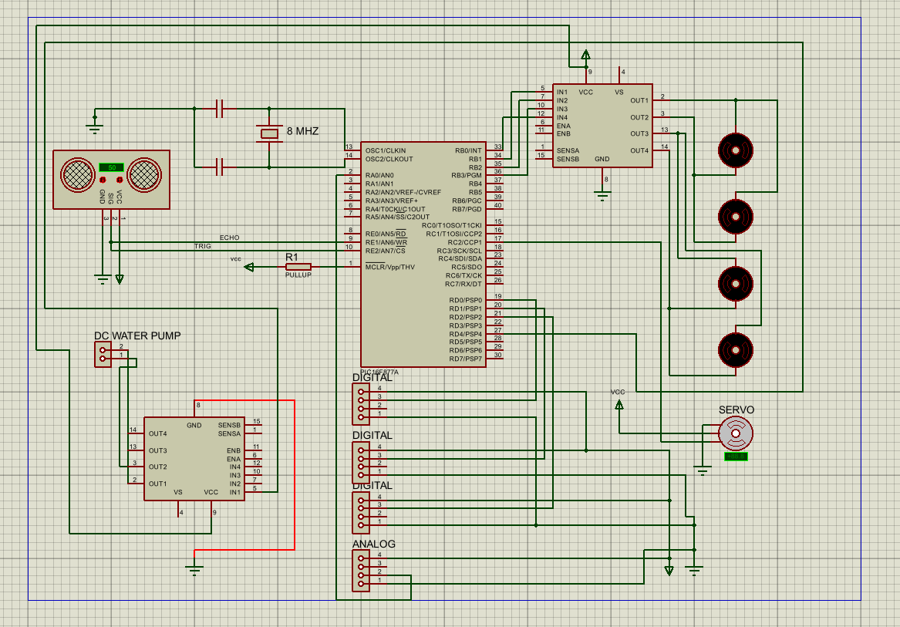

### Conclusion

This project successfully demonstrates the design and implementation of a basic autonomous firefighting robot using the PIC16F877A microcontroller. The robot can detect fire using flame sensors, navigate around obstacles using an ultrasonic sensor, and extinguish fire with the help of a servo-controlled water pump system. The integration of embedded control systems with mechanical components provides a strong foundation for real-time autonomous operation in controlled environments. The project highlights the potential of robotics in hazardous scenarios where human intervention may be unsafe.